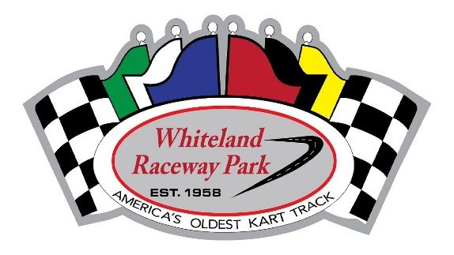
Race Day Format

8-10 Minute practice session
8 lap heat races
10 lap Kid kart novice / kid kart race
15 lap Junior class races
20 lap Adult class races
15 lap Master class races

Racers will pill draw for their starting position in their heat race. We will start a max of 10 karts per heat race, you will be placed into your main by your finishing position in your heat race.
** Heat race winners starting position for the A-Main will revert back to your fastest lap in your heat race if there is more than one heat race for your class.

2020 WRP Race Format Breakdown
Heat #1 Lineup |  |  | B-Main Lineup
Lowest Draw | Draw 4 |  | Heat #1 P7 | Heat #2 P7
Draw 7 | Draw 10 |  | Heat #3 P7 | Heat #1 P8
Draw 13 | Draw 16 |  | Heat #2 P8 | Heat #3 P8
Draw 19 | Draw 22 |  | Heat #1 P9 | Heat #2 P9
Draw 25 | Draw 28 |  | Heat #3 P9 | Heat #1 P10
 |  |  | Heat #2 P10 | Heat #3 P10
Heat #2 Lineup
Draw 2 | Draw 5 |  | A-Main Lineup
Draw 8 | Draw 11 |  | Heat Winner ** | Heat Winner **
Draw 14 | Draw 17 |  | Heat Winner ** | Heat #1 P2
Draw 20 | Draw 23 |  | Heat #2 P2 | Heat #3 P2
Draw 26 | Draw 29 |  | Heat #1 P3 | Heat #2 P3
 |  |  | Heat #3 P3 | Heat #1 P4
Heat #3 Lineup |  |  | Heat #2 P4 | Heat #3 P4
Draw 3 | Draw 6 |  | Heat #1 P5 | Heat #2 P5
Draw 9 | Draw 12 |  | Heat #3 P5 | Heat #1 P6
Draw 15 | Draw 18 |  | Heat #2 P6 | Heat #3 P6
Draw 21 | Draw 24 |  | B-Main P1 | B-Main P2
Draw 27 | Highest Draw |  | B-Main P3 | B-Main P4
 |  |  | B-Main P5 | B-Main P6

